Tuesday, December 18, 2018

CHAPTER 9

P.P.9.1 amplitude = 30
phase = –75
angular frequency () = 4 = 12.57 rad/s
period (T) = = 500 ms
frequency (f) = = 2 Hz

P.P.9.2
, rad/s
Compare this with
indicates that the phase angle between and is
145 + 65 = 210

Thus, i₁ leads i₂ by 210

P.P.9.3 (a) (5 + j2)(-1 + j4) = -5 + j20 – j2 – 8 = -13 + j18
560 = 2.5 + j4.33
(5 + j2)(-1 + j4) – 560 = -15.5 + j13.67
[ (5 + j2)(-1 + j4) – 560 ]* = –15.5 – j13.67

- 340 = 2.298 + j1.928
10 + j5 + 340 = 12.298 + j6.928 = 14.11529.39
–3 + j4 = 5126.87
2.823-97.48 = –0.3675 – j2.8
1030 = 8.66 + j5
8.293 + j7.2

P.P.9.4 (a) v = 7 cos(2t + 40)

The phasor form is
V = 740 V

- Since –sin(A) = cos(A + 90),
i = –4 sin(10t + 10) = 4 cos(10t+10 + 90)
i = 4 cos(10t + 100)
The phasor form is
I = 4100 A

P.P.9.5 (a) Since –1 = 1±180 (we can use either sign)
V = –2540 = 25(40–180) = 25–140
The sinusoid is
v(t) = 25 cos(t – 140) V or 25 cos(ωt + 220˚) V

(b) I = j (12 – j5) = 5 + j12 = 1367.38
The sinusoid is
i(t) = 13 cos(t + 67.38) A

P.P.9.6 Let v(t) = –10sin(ωt–30˚) + 20cos(ωt+45˚)
= 10cos(ωt–30˚+90˚) + 20cos(ωt+45˚)
Taking the phasor of each term
V = 1060 + 2045
V = 5 + j8.66 + 14.142 + j14.142
V = 19.142 + j22.8 = 29.7749.98˚
Converting V to the time domain
v(t) = 29.77 cos(t + 49.98) V

P.P.9.7 Given that
we take the phasor of each term to get
2j V +5 V +V = 50-30, = 5
V [j10 + 5 – j(10/5)] = V (5 + j8) = 50-30
V =
V = 5.3-88
Converting V to the time domain
v(t) = 5.3 cos(5t – 88) V

P.P.9.8 For the capacitor,
V = I / (jC), where V = 1030, = 100
I = jC V = (j100)(50x10⁻⁶)(1030)
I = 50120 mA
i(t) = 50 cos(100t + 120) mA

P.P.9.9 V_{s} = 2030, = 10
Z = 4 + jL = 4 + j2

I = V_{s} / Z = = 4.4723.43
V = jL I = j2 I = (290)(4.4723.43) = 8.94493.43

Therefore, v(t) = 8.944 sin(10t + 93.43) V
i(t) = 4.472 sin(10t + 3.43) A

P.P.9.10
Let Z₁ = impedance of the 1-mF capacitor in series with the 100- resistor
Z₂ = impedance of the 1-mF capacitor
Z₃ = impedance of the 8-H inductor in series with the 200- resistor

Z₁ =
Z₂ =
Z₃ =

Z_{in} = Z₁ + Z₂ || Z₃ = Z₁ + Z₂ Z₃ / (Z₂ + Z₃)
Z_{in} =
Z_{in} = 100 – j100 + 49.52 – j95.04
Z_{in} = (149.52 – j195)

P.P.9.11 In the frequency domain,
the voltage source is V_{s} = 20100
the 0.5-H inductor is jL = j (10)(0.5) = j5
the -F capacitor is

Let Z₁ = impedance of the 0.5-H inductor in parallel with the 10- resistor
and Z₂ = impedance of the (1/20)-F capacitor

Z₁ = 10 || j5 = = 2 + j4 and Z₂ = -j2
V_{o} = Z₂ / (Z₁ + Z₂) V_{s}
V_{o} =
V_{o} = 35.36–105
v_{o}(t) = 35.36 cos(10t – 105) V

P.P.9.12 We need to find the equivalent impedance via a delta-to-wye transformation as shown below.

+

4530 V

b

a

n

c

Z_{cn}

Z_{bn}

Z_{an}

10

5

-j2

Z_{an} = = = 0.32 + j3.76
Z_{bn} = = = -0.24 – j2.82
Z_{cn} = = = 0.96 – j0.72

The total impedance from the source terminals is
Z = Z_{cn} + (Z_{an} + 5 – j2) || (Z_{bn} + 10)
Z = Z_{cn} + (5.32 + j1.76) || (9.76 – j2.82)
Z = Z_{cn} +
Z = 0.96 – j0.72 + 3.744 + j0.4074
Z = 4.704 – j0.3126 = 4.714-3.802

Therefore,
I = V / Z =
I = 9.546 33.8 A

Let us now check this using PSpice. The solution produces the magnitude of I = 9.946E+00, and the phase angle = 33.803E+00, which agrees with the above answer.

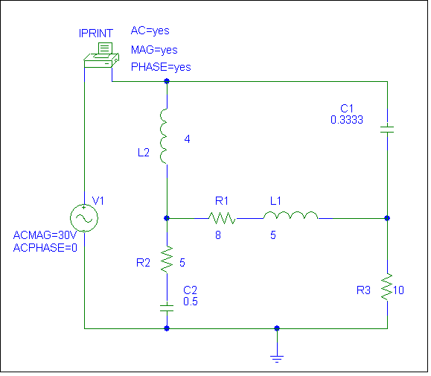

ACMG=45V
ACPHASE=0

P.P.9.13 To show that the circuit in Fig. (a) meets the requirement, consider the equivalent circuit in Fig. (b).

Z = -j10 || (10 – j10) = = = 2 – j6

+

V_{o}

10

-j10

+

V_{i}

(a)

10

-j10

V₁

+

10

Z = 2j6

V_{i} = 60 V

+

V₁

(b)
V₁ =
V_{o} = V₁ = =
V_{o} = 20∠–90˚

This implies that the RC circuit provides a 90 lagging phase shift.
The output voltage is = 20 V rms

P.P.9.14
the 1-mH inductor is jL = = j31.42
the 2-mH inductor is jL = = j62.83

Consider the circuit shown below.

+

V_{o}

j31.42

10

+

V_{i}

j62.83

50

V₁

Z = 10 || (50 + j62.83) =
Z = 9.205 + j0.833 = 9.2435.17

V₁ = Z / (Z + j31.42) V_{i} =
= [(9.243∠5.17˚)/(33.54∠74.07˚)]10 = 2.756∠–68.9˚

V_{o} = V₁ = = 1.7161–120.39

Therefore,
magnitude = 1.7161 V
phase = 120.39
phase shift is lagging

P.P.9.15 Z_{x} = (Z₃ / Z₁) Z₂

Z₃ = 12 k
Z₁ = 4.8 k
Z₂ = 10 + jL = = 10 + j9.425
Z_{x} = (10 + j9.425) = 25+ j23.5625

R_{x} = 25, X_{x} = 23.5625 = L_{x}
i.e. A 25- resistor in series with a 0.625-H inductor.

